Limehurst Primary School

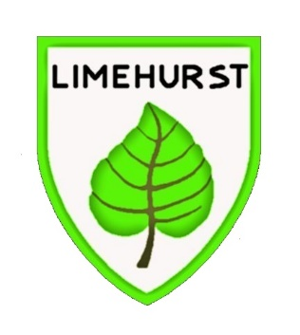

Allergy & Intolerance Policy

Developed: September 2026
Review: September 2028

- Introduction

This policy has been developed in accordance with the ‘Allergy Safety in Schools’ Department for Education statutory guidance published in July 2026. Limehurst Primary School has adopted the principles and recommendations contained within this guidance to support the effective management of allergies and anaphylaxis within the school environment.
The guidance was produced by the Department for Education in partnership with Anaphylaxis UK, and the school's procedures have been aligned to reflect current statutory requirements and recognised best practice in allergy management.
In line with Benedict’s Law, we are committed to providing a safe, inclusive, and welcoming environment for all children, young people, staff, and visitors with allergies. Recognising the serious and potentially life-threatening risk posed by anaphylaxis, this dedicated policy establishes robust risk-mitigation measures and emergency response protocols.
Allergy is a spectrum of different allergic diseases. Reactions occur when a susceptible person is exposed to something (an “allergen”) they are allergic to. Asthma, food allergy, eczema and seasonal rhinitis (hay fever) are all forms of allergy

- Common Cause of Allergic Reactions
Limehurst Primary School has a whole school awareness approach, because it ensures all staff and students are aware of what allergies are, the importance of avoiding the individuals' allergens, the signs & symptoms, how to deal with allergic reactions and to ensure procedures are in place to minimise risk of exposure
The most common causes of "whole body" allergic reactions - including anaphylaxis - are:
• Foods (e.g. peanuts, tree nuts, cow’s milk/dairy foods, egg, wheat, fish/shellfish and
sesame);
• Insect stings (e.g. bee, wasp);
• Medication (e.g. antibiotics, pain medicines such as ibuprofen);
• Latex (e.g. rubber gloves, balloons, swimming caps).
Even for food allergy, the vast majority of anaphylaxis reactions require the person to have eaten the food, although less serious allergic reactions can happen through skin or other contact. Anaphylaxis reactions due to skin contact are very rare. Students who have a skin reaction need monitoring for at least an hour.

3.Staff Training
The school recognises the importance of ensuring staff have the knowledge and confidence to respond appropriately to allergic reactions and anaphylaxis.
All staff receive Allergy and Anaphylaxis Awareness training delivered by the School Nursing Service. Following the introduction of Benedict's Law, additional training has been provided in September 2026, to ensure staff understand their responsibilities in relation to allergy management, recognising the signs and symptoms of an allergic reaction and anaphylaxis, and responding appropriately in an emergency.
Training includes:
- Understanding common allergens and allergy risks within the school environment.
- Recognising the signs and symptoms of allergic reactions and anaphylaxis.
- Knowing the school's procedures for managing pupils with allergies.
- Awareness of Individual Healthcare Plans (IHCPs).
- The emergency administration of adrenaline auto-injectors (AAIs), where appropriate.

4.Minimising Risk and Exposure to Allergens
The School’s position is not to guarantee a completely allergen free environment, rather to minimise the risk of exposure by hazard identification, instruction and information. This will encourage self-responsibility to all those with known allergens to make informed decisions on food choices and to provide help and assistance for our youngest pupils. It is also important that the School has clear plans for an effective response to possible emergencies. It is also important that the School has clear plans for an effective response to possible emergencies.
Minimising risk and the exposure to allergens is central to ensuring that individuals with allergies are safe from harm. Even a small amount of allergen can cause a reaction. Any food can cause a reaction with serious consequences for the individual and Limehurst Primary School will only eliminate a food following a risk assessment supported by medical advice when necessary. Where a food is restricted, this will be to the smallest area for the time necessary; for example, the cooking room for the duration of the lesson when the student with allergy is cooking. Blanket bans, especially to nuts, create a false sense of security. Whilst there are 14 key food allergens that cause over 90% of reactions, any food can cause a reaction;

- Cereals containing Gluten
- Celery including stalks, leaves, seeds and celeriac in salads
- Crustaceans, (prawns, crab, lobster, scampi, shrimp paste)
- Eggs - also food glazed with egg
- Fish - some salad dressings, relishes, fish sauce, some soy and Worcester sauces
- Soya (tofu, bean curd, soya flour)
- Milk and dairy - also food glazed with milk
- Nuts, (almonds, hazelnuts, walnuts, pecan nuts, Brazil nuts, pistachio, cashew and macadamia (Queensland) nuts, nut oils, marzipan)
- Peanuts - sauces, cakes, desserts, ground nut oil, peanut flour
- Mustard - liquid mustard, mustard powder, mustard seeds
- Sesame Seeds - bread, bread sticks, tahini, hummus, sesame oil
- Sulphur dioxide/Sulphites (dried fruit, fruit juice drinks)
- Lupin, seeds and flour, in some bread and pastries
- Molluscs, (mussels, whelks, oyster sauce, land snails and squid)
The allergy to nuts is the most common high risk allergy however, it is important to ensure that all allergies and intolerances are treated equally as the effect to the individual can be both life-threatening and uncomfortable, if suffered.
Limehurst Primary school will ensure that the risk of exposure is minimised by;
• All school staff allergy training every year
• Educating students through awareness assemblies and within PSHE
• Communicating with all visitors, temporary staff and cover staff that they will be teaching a student with an allergy and ensuring that the member of staff has been trained in allergy and anaphylaxis emergency response.
• Working closely with parents/carers and health professionals to understand the student's
Allergy.
• Monitoring this policy to ensure that the agreed practices are implemented.
• Establishing and maintaining high hygiene standards amongst staff, students and visitor.

5.Food Provision and Catering
Limehurst Primary School will manage the risks associated with food allergies and provide clear information regarding allergens in food by:
- Maintaining accurate records of pupils with medically diagnosed food allergies and intolerances.
- Ensuring that allergy information is communicated promptly to catering staff and relevant school staff.
- Recording confirmed allergies and intolerances within the School Grid meal ordering system.
- Utilising School Grid allergen controls to automatically remove menu options containing a pupil's identified allergen(s).
- Providing parents/carers with access to menu information to enable informed meal choices for their child.
- Ensuring catering staff are aware of pupils with food allergies and are trained in the school's allergy management procedures.
- Maintaining up-to-date allergen information for all menu items and recipes provided by the catering service.
- Obtaining allergen information from suppliers and reviewing this information whenever menus or ingredients change.
- Implementing robust food hygiene and food preparation procedures to minimise the risk of cross-contamination.
- Serving meals for pupils with recorded allergies on a purple tray, providing a clear visual identifier to all dining hall staff that the child has an allergy or intolerance.
- Using yellow allergen identification wristbands where appropriate and ensuring they are clearly visible during lunch service.
- Displaying Allergy Identification Cards (AICs) within the kitchen to support safe meal preparation and service.
- Work with the catering provider and School Cook to ensure all catering staff, including new starters, receive appropriate allergy awareness information and training.
- Working closely with parents/carers where additional arrangements may be necessary to support a pupil's dietary needs.
- Making clear to parents/carers that, whilst the school takes all reasonable precautions to minimise allergen exposure, it cannot guarantee a completely allergen-free environment due to the potential risk of cross-contamination.
- Ensure the contract with the school catering company is compliant with the Food Standards Authority allergen management regulations.
- Teach students not to food share, trade food or share utensils or food containers with the reasons why.
- Where food is not directly provided by the school (for example brought in as treats or to celebrate birthdays) parent/carer permission will sought in advance to ensure inclusion and safety for students with allergies.
Where a pupil's allergy cannot be safely managed through the school's catering arrangements, parents/carers may be asked to provide a packed lunch from home following discussion with the school.

6. Procedures & Responsibilities

The School has clear procedures and responsibilities to be followed in meeting the needs of pupils with medical needs relating to food allergies or intolerances.

6.1 Initial Information Provided Regarding Food Allergies or Intolerances
The parents or carers of all new starters to the school are required to complete a data collection form that asks for the details of any food intolerances or allergies. The school office team will check the form to see if allergies or food intolerances are listed and if so, will follow this up with a verbal conservation with parent/carer for further information & request medical proof.
For children starting in the nursery & reception classes, information regarding food allergies will be discussed during pre-school visits alongside any other medical needs.
If required, a meeting can be arranged between the parent/carer and either the School Business Manager or SENCO to further discuss a child’s needs. They will then record and relay this information to school staff and/or food providers such as breakfast club staff, catering staff and midday staff.
It is parents’ responsibility to ensure that if their child’s medical needs change at any point that they make the school aware and a revised medical needs/allergy information form must be completed.
Members of staff or volunteers will be asked to disclose any food allergies as part of their induction.
6.2 How the School Uses this Information
All medical needs and allergen/food intolerance information received is stored confidentially within the school’s management information system (SIMS) and paper records are held centrally in the school office so that the information can be accessed by appropriate members of staff as required.
Medical information for pupils is private and confidential however in order to ensure that medical needs can be properly managed, information is shared with school staff. This is done in several ways:
- Before the start of a new academic year, a spreadsheet detailing medical needs information/details of food allergies, are shared with the receiving class teacher as part of our transition process. This information is collated by the School Business Manager and passed onto teachers. It is the class teachers’ responsibility to ensure that they are familiar with the information provided and that any other adults working with the children are aware of their needs as well.
- Key medical needs information is on a separate tab at the bottom of the daily electronic register as an additional reminder to any new staff (e.g. supply teacher) who may be teaching the class.
- The school office staff will inform the school kitchen of any pupils who have food allergies or intolerances. An Allergy Identification Board containing a photograph and details of every child with an allergy/food intolerance, is available in the kitchen during every food service.
- Where a food allergy significantly impacts on a child’s day to day activity, a care plan might be put in place e.g. a child who requires tube feeding or is required to eat at a separate time. This will be constructed in conjunction with the SENCO, school staff, parents and healthcare professionals.

6.3 Lunchtime

Children may have either a school meal or a packed lunch from home. School meals must be selected in advance by parents/carers through School Grid.

Where a medically confirmed food allergy or intolerance has been recorded, the allergen information will be added to School Grid. The system will automatically remove any menu options containing the identified allergen(s), ensuring that only suitable meal choices are available for selection.

Parents/carers are responsible for selecting their child's meals from the options available on School Grid. Menus are published in advance and may occasionally be subject to change due to supplier availability or unforeseen circumstances. While every effort will be made to provide suitable alternatives, the school cannot guarantee a completely allergen-free environment due to the risk of cross-contamination within the catering operation.

An Allergy Identification board containing a photograph and details of every child with an allergy/food intolerance, is available in the kitchen.
The school kitchen caters for a range of food allergy needs. Children are told that they are not allowed to share food at lunchtimes. Midday supervisors observe and assist the children at lunchtime in order to reduce the opportunity for children to share food, although we cannot guarantee that this will not happen.

7.Responsibilities

  - School Staff Responsibilities

- Supporting those children who have school dinners with their menu choices.
- Liaising with parents regarding the management of food allergies.
- Associate Head Teacher to organises Allergy & Anaphylaxis training at the beginning of as required
- The school has a number of first aiders who would be called upon to assist in cases of allergic reaction including anaphylaxis. A number of staff have also had training in how to administer an epi-pen to those children who have an Individual Healthcare Plan (IHCP).
- The school will contact parents and the emergency services, if required, in the event that a child suffers an allergic reaction. The school’s Administration of Medicines and Supporting Medical Conditions in School policy outlines the school’s response to medical emergencies.
- Ensuring that pupils issued with an allergen identification yellow wristband wear it during lunch service and that it remains clearly visible to catering staff at all times.

7.2 Catering Staff Responsibilities

Catering staff will:

- familiarise themselves with the allergy & intolerance needs of our pupils in order for correct meals to be consumed;

- identify & record ingredients for every recipe on the menu (and substitute recipes) that may pose a risk to allergy sufferers, enabling them to assist in relevant children’s choices;

- Ensure rigorous food hygiene is maintained to reduce risk of cross contamination;

- Ensure suppliers provide information regarding the content of their products.

- When the School Grid serving screen identifies a pupil with a recorded food allergy or intolerance, ensure that the pupil's meal is served on a purple tray. The purple tray acts as a clear visual indicator to all staff in the dining hall that the pupil has an allergy or intolerance and that additional care should be taken when supervising and serving their meal.

- Ensure pupils issued with allergen identification wristbands are wearing them and that they are clearly visible throughout the lunch service.

7.3 Parental Responsibilities
Parents are responsible for:
- Completing the data collection form and ensuring that any information regarding food allergies for their child is included.
- Completing a Food Allergy Notification form if requested by school to do so.
- Updating the school if their child’s medical needs change at any point. Parents are requested to keep the school up to date with any changes in allergy management with regards to clinic summaries, re-testing and new food challenges.
- Ensuring that any required medication (Epi-pens or other adrenalin injectors, inhalers and any specific antihistamine) is supplied, in date and replaced as necessary. The parents of all children who have an epi-pen in school must complete a written Individual Healthcare Plan in conjunction with the SENCO.
- Attending any meeting as required to share further information about their child’s food allergy, to plan for food management in school or to complete an Individual Care Plan.
- Informing school if an episode of anaphylaxis occurs outside of school.

7.4 Pupil Responsibilities
- Children of any age must be familiar with what their allergies are and the symptoms they may have that would indicate a reaction is happening.
- Children are encouraged to take increased responsibility for managing choices that will reduce the risk of allergic reaction. Expectations are age appropriate.
- Children are not allowed to share food with each other.

8. Identification of Individuals with Allergies
Admissions Data Collection: Limehurst Primary School collects detailed medical information from parents/carers regarding known allergies, dietary restrictions, and treatment histories prior to admission via the data collection form.
Information Sharing: UK GDPR does not prevent the sharing of a student’s health information). Relevant information is securely compiled and shared as necessary in a controlled way with teaching staff, support staff, supply cover, and catering teams while maintaining appropriate data privacy.
Transition: Allergy information and existing care plans are shared as part of a student’s transition. Limehurst Primary School will request allergy information from the previous school or setting and will consider whether any of the arrangements are suitable to implement. The SENCO School work with parents/carers and the student if appropriate to write a new IHP. Staff will provide information about students for transition visits ahead of a formal move.
Staff: pre-employment questionnaires will ask whether they have any allergies. If an allergy is declared, there will be a discussion and action plan created to ensure that the member of staff has a safe working environment.

9. Immunoglobulin E allergy (IgE Allergy)
An IgE allergy (Immunoglobulin E allergy) is a type of allergy where the body's immune system produces IgE antibodies in response to a normally harmless substance (allergen), such as peanuts, milk, eggs, fish, shellfish, pollen, insect stings, or certain medications.

When a person with an IgE-mediated allergy comes into contact with the allergen, their immune system can react very quickly, often within minutes, causing symptoms such as:
- Hives (urticaria)
- Itching
- Swelling of the lips, face, tongue or throat
- Wheezing or difficulty breathing
- Vomiting or abdominal pain
- Dizziness or collapse
- Anaphylaxis (a severe, life-threatening allergic reaction)

For schools, IgE-mediated allergies are particularly important because they can result in rapid and severe reactions, often requiring emergency treatment with an Adrenaline Auto-Injector (AAI) such as an EpiPen, Jext or Emerade.

10. Student Individual Healthcare Plans (IHPs) and Allergy Action Plans
Allergy Action Plans

Pupils who have a known allergy to a food or insect stings should be issued with an appropriate allergy action plan by their healthcare professional. Allergy action plans are medical documents designed to facilitate an emergency response to reactions including anaphylaxis, by people without any special medical training or equipment other than access to an adrenaline device (e.g. AAI “pen”). The relevant healthcare professional is responsible for determining the content of each child or young person’s allergy action plan. They are not issued for all allergies. Students with non-IgE allergies don’t experience anaphylaxis and so an allergy action plan is not issued.
• These are clinical documents that are created by a GP / allergy nurse or allergy clinic. They detail the student’s allergy and medication.
• These contain parent/carer contact details and must be signed by the parent/carer as this is the parental authority to administer mediation including the administration of spare adrenaline devices.
• These will only be updated by the medical professional following a review of the student’s allergy management, this could be annually or 5 yearly. Parents/carers or school need to update the photo of the student annually so that the student is recognisable.

Asthma Action Plans
Pupils with asthma should be provided with an asthma action plan by the relevant healthcare professional. This provides everything staff need to know about a pupil’s asthma in one place, including information about their triggers, symptoms, medicines to be used if they have asthma symptoms and when to seek emergency help when they have an asthma attack.
Limehurst Primary School will retain a copy of the Asthma Action Plan on the pupil's SIMS record and alongside their inhaler to ensure it is readily accessible to staff when required. Staff working closely with the pupil will be made aware of the plan and any actions necessary to support the pupil's asthma management during the school day.
Allergy and/or asthma action plans should be attached to the child or young person’s IHP where one has been created. The plans include medical and parental consent for staff to administer emergency medicines, such as adrenaline for anaphylaxis or reliever inhaler in the event of an asthma attack. Action plans are reviewed and updated by healthcare professionals at regular intervals. Whenever an updated action plan becomes available, the pupil’s IHP should be reviewed to incorporate it even if it is not due to be reviewed at that time.

Individual Healthcare Plans (IHPs)

Individual healthcare plans are an essential communication tool that provide clarity about the
arrangements which need to be in place to ensure that a student is fully included in the life of the school. It will identify exact risk-mitigation measures that need to be followed.
Individual Healthcare Plans are school owned documents that are co-created by school, parents/carers and students.
They should include any advice received from health professionals. If there is no advice from health professionals, information and support can be requested of the school nurses if this is needed.
Not all children with an allergy will require an IHP. Some allergies will have little or no impact on the child or young person while they are at school nor will pose a risk to the pupil. Some allergies will not require arrangements which are additional to or different from those made generally. IHPs are not necessary for all individuals managing allergies. However, pupils should have an IHP if:
• they have an allergy which has a functional impact on them in school
• they are at risk of harm as a result of their allergy; and
• they require arrangements which are additional to or different from those made generally.

It is essential that IHPs are personalised around the pupil and their current needs:
• The school should always discuss the circumstances with the pupil themselves (where appropriate) and with their parents/carers. This is essential to understand the impact the allergy has on the individual – in particular the impact on their health, education and wellbeing. The same condition can have very different effects on individuals. Strong co production with the pupil and their parents/carers is crucial to establish confidence that the allergy will be well managed, thereby reducing or avoiding anxiety.
• The school should refer to the advice provided by the healthcare professionals involved in providing care to the child or young person. This can include letters or advice from a GP, consultant or community nurse. It will also include care plans and allergy action plans issued by healthcare professionals and any instructions for prescribed medication (for example adrenaline devices) which may to be administered while the child or young person is in education. The school will need identify arrangements that need to be in place, taking account of advice from the relevant healthcare professionals. This may include school-level adjustments and emergency response arrangements, alongside arrangements involving health services, where support falls under NHS responsibility
• Where an allergy is suspected but no advice is available from a healthcare professional, the school should not dismiss the pupils’ needs or the information they receive. They should put arrangements in place to support them based on the best assessment that can be made of the likely risk to the pupil’s health, education and wellbeing. They should then seek further advice from healthcare professionals.
• The school may also wish to seek advice from school nursing teams on how best to support pupils with specific allergies. In some cases (especially rare, complex or multi system conditions), advice should also be sought from clinicians with relevant specialist knowledge. The local authority’s Designated Medical Officer and/or Designated Clinical Officer may be able to help identify and engage with relevant specialists if necessary.
It is good practice to review IHPs annually or when staff change however they must be reviewed if an incident or near miss occurs. They need to be brought to the attention of supply or cover staff and be passed on during transition to a new school.
Limehurst Primary School will ensure that:

• Students with an allergy action plan and/or an asthma plan have an individual healthcare plan
• Students without an allergy action plan or asthma plan but have an allergy that needs active management over and above what other students need will have an individual healthcare plan.
• Individual healthcare plans are created whilst students are waiting for a diagnosis.

11. Symptoms Of Allergic Reactions
Mild to moderate allergic reactions which do not involve Airway/Breathing/Circulation can be treated with oral antihistamines. For a child or young person, telephone their parent or emergency contact to tell them about the reaction. Do not leave the child or young person unattended. The child or young person does not normally need to be sent home or require urgent medical attention. They should be observed in a safe place for at least 60 minutes after reaction, as mild reactions can sometimes develop into anaphylaxis.
Ear/nose/throat symptoms: runny or blocked nose, itchy nose, sneezing, painful sinuses. Headaches, post nasal drip, loss of sense of smell/taste, sore throat/swollen larynx (voice box), itchy mouth and or throat and blocked ears.
Eye symptoms: watery, itchy, prickly, red, swollen eyes. Allergic “shiners” (dark areas under the eyes due to blocked sinuses).
Airway symptoms: wheezy breathing, difficulty in breathing and or coughing (especially at night time).
Digestion: swollen lips, tongue, itchy tongue, stomach ache, feeling sick, vomiting, constipation and or diarrhoea.
Skin: urticarial- wheals or hives-bump, itchy, raised areas and or rashes. Eczema – cracked, dry, weepy or broken skin. Red cheeks. Angioedema – painful swelling of the deep layers of the skin.

11.1 Symptoms of severe reaction/anaphylaxis
Anaphylaxis reactions involve the Airway/Breathing/Circulation (“ABC”).
This could include any of the above together with:
A: Airways: Swelling in the throat, tongue or upper airways (tightening in the throat, hoarse voice, difficulty swallowing).
B: Breathing: Sudden onset wheezing, breathing difficulty, persistent cough,noisy breathing
C: Circulation: Dizziness, feeling faint, sudden sleepiness, tiredness,confusion, pale clammy skin, loss of consciousness
If in doubt, always treat for anaphylaxis - DFE Allergy Safety in Schools, July 2026
(see figure 1 below).

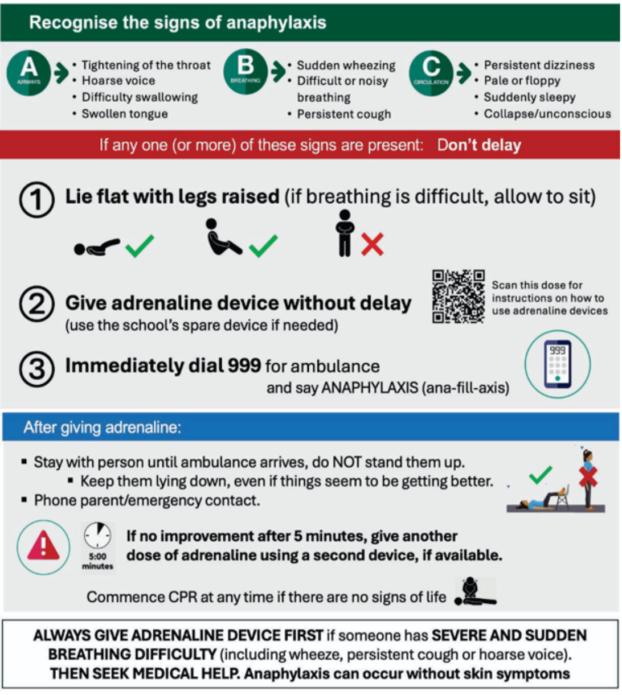
Figure 1: Management of anaphylaxis

12.Medication and Adrenaline Devices (ADs)
This policy has been written and should be read, in conjunction with the anaphylaxis policy.
The school maintains a supply of emergency allergy medication within the School Office safe, including antihistamines and four spare Adrenaline Auto-Injectors (AAIs). These are not a replacement for a student’s own adrenaline device. Students prescribed adrenaline are expected to have their own adrenaline devices with them at school for use in an emergency. A spare AAI can be administered as a substitute for a pupil’s own prescribed AAI, if this cannot be administered correctly, without delay.
The school supply of allergy medication is stored securely and are readily accessible to trained staff in the event of an allergic reaction or suspected anaphylaxis. The school maintains a centralised register and regularly monitors expiry dates and replaces medication as required to ensure that all emergency medication remains in date and available for use when needed.
People at risk of anaphylaxis are prescribed two adrenaline devices which are stored in a suitably safe and easily accessible location in their classroom and also one in the school safe. These will also be held by the trip/group lead during any off-site activities and available for any curriculum activities outside of the classroom (e.g. PE, dining etc). which they/their responsible member of staff, should carry with them at all times. This includes the journey to and from;

- School,
- The classroom
- Lunch area
- Playground
- sports field
- When on visits or trips
12.1 Storage of Personal AAI’s;
Depending on their level of understanding and competence, pupils will be encouraged to take responsibility for their own AAIs where appropriate. However, this will be not kept on their person but available (within easy access to them/staff) in a red medication bag for each class. This bag has all medication contained is clearly labelled and identifiable. This bag MUST accompany the child wherever they go (e.g. stored in class but taken to PE, outside at lunchtimes, to clubs and any off-site activities etc).Under no circumstances should these bags ever be locked away.

13. Management Of Food Allergies In Other Areas Of School Life
13.1 Rewards and Celebrations
On occasions, food items are used as part of the school’s reward system, this may include end of term tea parties/picnics. On these occasions, staff will endeavour to make suitable adjustments in order to ensure that children with food allergies feel included, e.g. substituting food items.
Sometimes children will bring items into school to distribute to classmates when it is their birthday. It is school policy that these items are not food items.
13.2 Curriculum Activities & After School Clubs
As part of the school curriculum, children may be involved in activities that involve preparing food or tasting food (e.g. tasting food from other countries). Teachers will take the needs of children with food allergies into account when planning these activities and will make modifications where possible to allow participation. When a third party is involved in delivering a food related workshop, the class teacher will be responsible for ensuring that the dietary needs of pupils are taken into consideration.
This also applies to after school clubs e.g. Cookery Club.

13.3 Educational Visits
The lead member of staff for an educational visit will ensure that food allergy considerations are made in any activity that may involve food.
When a child with a food allergy participates in a residential visit, their dietary needs will be planned for, in conjunction with the activity centre.

14. Safeguarding
Limehurst Primary School recognises that a safeguarding referral may be needed if an incident highlighted concern that the child or young person might be at an increased risk of being neglected, abused or exploited by persons inside or outside of their family unit because of their medical condition. This might occur where relevant information about a child or young person’s medical condition is not provided to a school, college or setting, or where they are repeatedly sent without essential medication, thereby putting the individual at risk.

15. Related Policies
This policy has due regard to all relevant legislation and guidance including, but not limited to, the following:
• Children and Families Act 2014

• The Human Medicines (Amendment) Regulations 2017

• The Food Information (Amendment) (England) Regulations 2019 (Natasha’s Law)

• Department of Health ‘Guidance on the use of adrenaline auto-injectors in schools’

• DfE ‘Supporting pupils at school with medical conditions’

• DfE ‘Allergy guidance for schools’

This policy should be read alongside:
- Department for Educations ‘Allergy Safety in Schools – July 2026’
- Children Act 1989
- Supporting Pupils with Medical Conditions Policy
- Administration of Medicines Policy
- Anaphylaxis Policy
- First Aid Policy
- Health and Safety Policy
- Educational Visits Policy
- Safeguarding and Child Protection Policy
- Keeping Children Safe in Education
- Risk Assessment Policy
- SEND Policy
- Intimate Care Policy (where applicable)

APPENDIX 1

Allergy Notification Process - September 2026

1. Parent/Carer Notification
The parent/carer must complete the Pupil Data Collection Form prior to their child being admitted to the school (including Nursery, Reception, or in-year admissions).
2. Initial School Follow-Up
The School Office will review the Pupil Data Collection Form to identify any declared allergies or intolerances. Where an allergy or intolerance is indicated, office staff will discuss this with the parent/carer to establish whether the condition has been medically diagnosed. Medical evidence will be required.
Parents/carers will be advised that they must provide supporting medical evidence and complete a Allergy Notification Form. One signed copy of the completed form will be provided to the parent/carer, and one copy will be retained by the school and attached to the pupil's SIMS record.
3. Explanation of School Procedures
Office staff will explain that, while the school takes reasonable steps to minimise the risk of allergen exposure through risk assessment, staff training, and the provision of information, it cannot guarantee a completely allergen-free environment.
Parents/carers will be advised that, due to the wide range of ingredients used within the school kitchen, there remains a risk of cross-contamination, even where a particular allergen is not intentionally included in a meal.
Where appropriate, office staff will discuss the option of providing a packed lunch for children with allergies.
The parent/carer must sign the acknowledgement section of the Food Allergy Notification Form to confirm that they understand and accept the school's position regarding allergen management and cross-contamination risks.
4. Notification and Recording Process
Upon receipt of the completed Food Allergy Notification Form and supporting medical evidence, the School Office will notify the Class Teacher and Catering Manager via email, attaching copies of all relevant documentation.
The following actions will then be completed:
- If an EpiPen or other emergency medication has been prescribed, the SENCO will complete an Individual Healthcare Plan (IHCP).
- The School Office will record the allergy/intolerance on SIMS and upload all supporting documentation.
- The School Office will produce an Allergy Identification Card (AIC) for display on the kitchen noticeboard.
- The Catering Manager will verbally brief all kitchen staff and record this communication within training records.
- A yellow allergen wristband will be provided where parents give permission. Staff must ensure that it is visible during lunch service.
- Until an AIC has been produced, the Catering Manager will ensure that kitchen staff can identify the pupil and are aware of their allergy requirements.
- The School Office and/or SENCO will inform all relevant staff members, including teachers, teaching assistants, midday supervisors etc.
- The Catering Manager will ensure that all new kitchen staff receive relevant pupil allergy information as part of their induction process.
5. Changes to Allergy Information
Parents/carers must notify the School Office in writing of any changes to their child's allergy or intolerance information.
The School Office will inform the SENCO, who will review and authorise any amendments to recorded information. The SENCO will then notify the Business Manager and Catering Manager of any updates to ensure records and procedures remain accurate and up to date.

APPENDIX 2

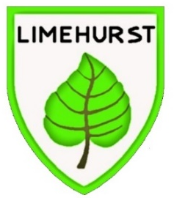
Limehurst Primary School
Pupil Dietary / Allergy Notification Form
You are required to complete this form because you have notified us that your child has a special dietary requirement. The information provided will be used to inform the school and school kitchen when providing meals for your child.
Please return this form to the school office.
SECTION 1: PUPIL DETAILS
Pupil Surname:
Pupil First Name:
Pupil Address & Postcode:
Male/Female: |  |  | Date of Birth:
Class:
Allergy Details / Special medical Dietary Requirement:
Symptoms of reaction:
Actions in case of reaction:
SECTION 2 : MEDICATION
Does your child require medication to be kept in school (E.G. antihistamine) | Y / N | IF YES, when would/does your child require the medication?
Does your child require an Epi-pen? |  | Do you consent to the use of the school Epi-pen in the event of an emergency?
I understand that it is my responsibility, as the parent/carer, to ensure that any Medication / Epi Pen I provide to school is always within the expiry date.
SIGNED:
SECTION 3: MEDICAL DETAILS (parent/carers of children with special medical diets must attach a supporting medical letter)
Name & Address of Doctor:
Phone number:
SECTION 4: SCHOOL RESPONSIBILITIES
It has been explained to me, as the parent/carer, that the School’s position is not to guarantee a completely allergen free environment, but to minimise the risk of exposure by hazard identification, instruction and information. That is - whilst a dish may not contain a specific allergen, due to the wide range of ingredients used in our kitchen, foods may be at risk of cross contamination by other ingredients.
It has been discussed with me that I may prefer to provide my child with a packed lunch so that I can control the ingredients in my child’s lunch
SECTION 5: PARENT/CARER SIGNATURE
Signed: |  |  | Date:

It is the responsibility of the parent/carer to notify the school office in writing of any changes to dietary requirements previously agreed. This must be supported with the appropriate medical evidence (GP/Doctor letter).
Please note that a photo ID card of your child will be produced for identification purposes and displayed in the school kitchen during food service times.
We collect the above data in order to help us provide school catering services. We will store it securely and manage it in accordance with GDPR principles. For more information, please see our Pupil Privacy notice on the school website;

